CPP Lecture Assignment 3:
/*1:Write a program to create student class with data members rollno, marks1,mark2,mark3.
Accept data (acceptInfo()) and display using display member function. Also display total,percentage and grade.*/
#include<iostream>
using namespace std;
class Student{
private:
int rollno, marks1, marks2, marks3;
int total;
double percentage;
char grade;
public:
void acceptInfo(){
cout<<"Enter roll no.: ";
cin>>rollno;
cout<<"\nEnter marks1: ";
cin>>marks1;
cout<<"\nEnter marks2: ";
cin>>marks2;
cout<<"\nEnter marks3: ";
cin>>marks3;
}
void displayInfo(){
cout<<"Roll No.: "<<rollno;
cout<<"\nMarks1: "<<marks1;
cout<<"\nMarks2: "<<marks2;
cout<<"\nMarks3: "<<marks3;
cout<<"\n Total: "<<total;
cout<<"\n Percentage: "<<percentage;
cout<<"\n Grade: "<<grade;
}
void calTotal(){
total = marks1 + marks2 + marks3;
}
void calPercentage(){
percentage = total / 300.00;
percentage = percentage * 100.00;
}
void calGrade(){
if(percentage > 90){
grade = 'A';
}
else if(percentage > 80 && percentage < 90){
grade = 'B';
}
else if(percentage > 70 && percentage < 80){
grade = 'C';
}
else if(percentage > 60 && percentage < 70){
grade = 'D';
}
}
};
int main(){
Student stdObj;
stdObj.acceptInfo();
stdObj.calTotal();
stdObj.calPercentage();
stdObj.calGrade();
stdObj.displayInfo();
return 0;
}
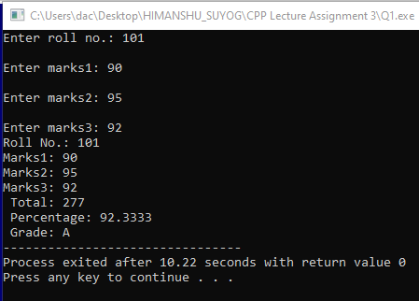

//2. Create a class Person with data members as name, age, city. Also add accept and display function. . Create the object of this class in main method and invoke all the methods in that class.
#include<iostream>
using namespace std;
class Person{
private:
string name;
int age;
string city;
public:
void displayInfo(){
cout<<"Person name is: "<<name;
cout<<"\nPerson age: "<<age;
cout<<"\nCity: "<<city;
}
void acceptInfo(){
cout<<"Enter person name: ";
cin>>name;
cout<<"\nEnter age: ";
cin>>age;
cout<<"\nEnter city: "<<endl;
cin>>city;
}
};
int main(){
Person p;
p.acceptInfo();
p.displayInfo();
return 0;
}
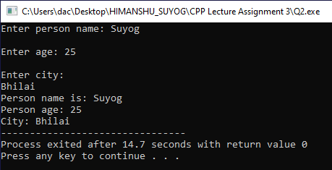

/*3. Create a class Date with data members as dd, mm, yy. Create AcceptDate function. Also add the display function.
Create the object of this class in main method and invoke all the methods in that class.*/
#include<iostream>
using namespace std;
class Date{
private:
int dd;
int mm;
int yy;
public:
void acceptDate(){
cout<<"Enter date: ";
cin>>dd;
cout<<"\nEnter month: ";
cin>>mm;
cout<<"\nEnter year: ";
cin>>yy;
}
void displayDate(){
cout<<"\nDate is: "<<dd<<"/"<<mm<<"/"<<yy;
}
};
int main(){
Date today;
today.acceptDate();
today.displayDate();
return 0;
}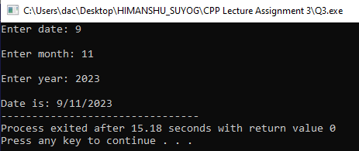
/*3. Create a class Book with data members as bname,id,author,price. Write AcceptBook function . Also add the display function. Create Default and Parameterized constructors. Create the object of this class in main method and invoke all the methods in that class.*/
#include<iostream>
using namespace std;
class Book{
private:
int id;
string name;
string author;
int price;
public:
void acceptBook(){
cout<<"Enter id: ";
cin>>id;
cout<<"\nEnter name: ";
cin>>name;
cout<<"\nEnter author: ";
cin>>author;
cout<<"\nEnter price: ";
cin>>price;
}
void displayBook(){
cout<<"\nBook id: "<<id<<" with name "<<name<<" who's author is "<<author<<" is priced at "<<"$"<<price; }
};
int main(){
Book b;
b.acceptBook();
b.displayBook();
return 0;
}
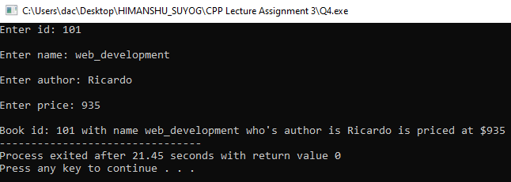

/*4. Create a class Point with data members as x,y. Add AcceptPoint and add the display function. Create the object of this class in main method and invoke all the methods in that class.*/
#include<iostream>
using namespace std;
class Point{
private:
int x, y;
public:
void acceptPoint(){
cout<<"Enter point x: ";
cin>>x;
cout<<"Enter point y: ";
cin>>y;
}
void displayPoint(){
cout<<"\nPoint is x: "<<x<<" and y is: "<<y;
}
};
int main(){
Point p;
p.acceptPoint();
p.displayPoint();
return 0;
}
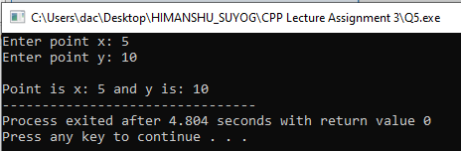

/*5. Create a class ComplexNumber with data members real, imaginary. Create AcceptComplexNumber() and the display function. Create the object of this class in main method and invoke all the methods in that class.*/
#include<iostream>
using namespace std;
class ComplexNumber{
private:
int real;
int imaginary;
public:
void acceptComplexNumber(){
cout<<"Enter real no.: ";
cin>>real;
cout<<"\nEnter complex no.: ";
cin>>imaginary;
}
void displayComplexNumber(){
cout<<"\nComplex number is: "<<real<<" + "<<imaginary<<"i";
}
};
int main(){
ComplexNumber complex;
complex.acceptComplexNumber();
complex.displayComplexNumber();
return 0;
}
